October 10, 2022

**BCS203193**

MUHAMMAD HARRIS – SECTION 4

Computer Organization & Assembly Language LAB

QUIZ

QUIZ

# Question 01

**Print the table of 2 upto 10.**

## Answer:

;print table of two till 10

.model small

;data segment

.data

lineone db "2 x 1 = 2","$"

linetwo db 0ah,0dh,"2 x 2 = 4","$"

linethree db 0ah,0dh,"2 x 3 = 6","$"

linefour db 0ah,0dh,"2 x 4 = 8","$"

linefive db 0ah,0dh,"2 x 5 = 10","$"

linesix db 0ah,0dh,"2 x 6 = 12","$"

lineseven db 0ah,0dh,"2 x 7 = 14","$"

lineeight db 0ah,0dh,"2 x 8 = 16","$"

linenine db 0ah,0dh,"2 x 9 = 18","$"

lineten db 0ah,0dh,"2 x 10 = 20","$"

;code segment

.code

;moving data segment to ax

mov ax,@data

mov ds,ax

;printing line 1

mov ah,9

mov dx, offset lineone

int 21h

;printing line 2

mov ah,9

mov dx, offset linetwo

int 21h

;printing line 3

mov ah,9

mov dx, offset linethree

int 21h

;printing line 4

mov ah,9

mov dx, offset linefour

int 21h

;printing line 5

mov ah,9

mov dx, offset linefive

int 21h

;printing line 6

mov ah,9

mov dx, offset linesix

int 21h

;printing line 7

mov ah,9

mov dx, offset lineseven

int 21h

;printing line 8

mov ah,9

mov dx, offset lineeight

int 21h

;printing line 9

mov ah,9

mov dx, offset linenine

int 21h

;printing line 10

mov ah,9

mov dx, offset lineten

int 21h

;terminating

mov ah,4ch

int 21h

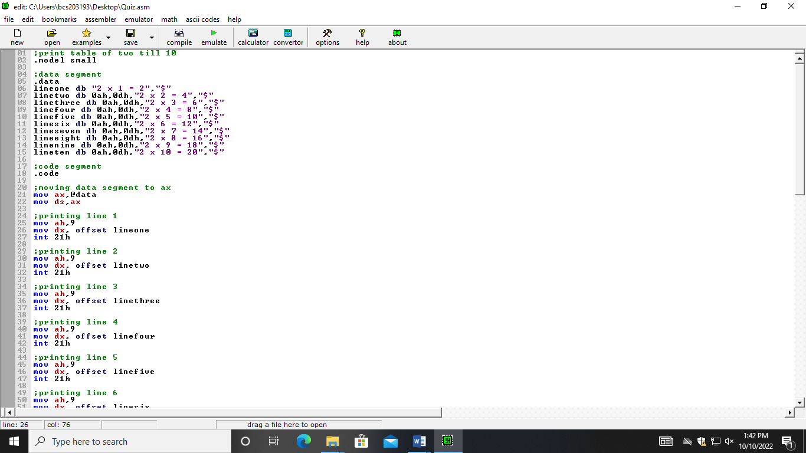

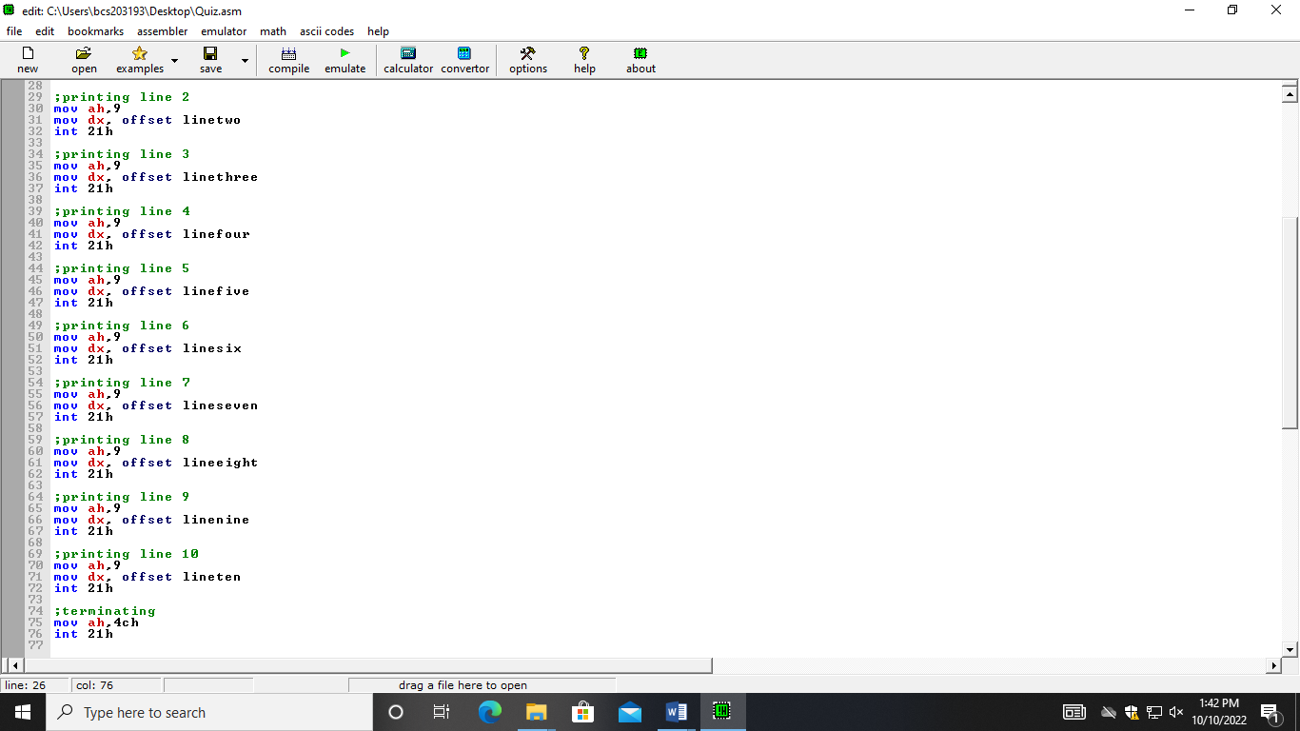

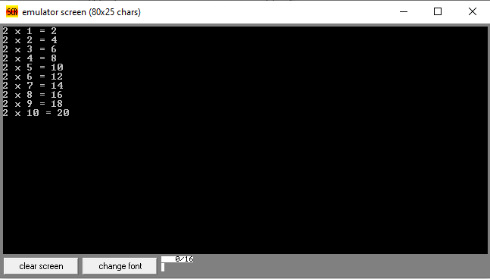

# Question 02

Store the value 6 in a variable A. Take another variable B and read its value from user. Calculate both sum and difference of A and B, store the results in variables; sum & diff. Display the results in the end.

**Note: Display proper messages while taking input and showing result**

## Answer:

.model small

;data segment

.data

str1 db "Enter a Number: $"

str2 db 0ah,0dh,"SUM: $"

str3 db 0ah,0dh,"DIFFERENCE: $"

val1 db 4d

;code segment

.code

;moving data to data segment

mov ax, @data

mov ds, ax

;printing str1

mov ah, 09

mov dx, offset str1

int 21h

;take input

mov ah, 01

int 21h

;moving input value to bl register

mov bl, al

;addition

mov cl, bl

add cl, val1

;adding ASCII

;add cl

;printing str2

mov ah, 09

mov dx, offset str2

int 21h

;moving result to dl resiter

mov dl,cl

;printing result

mov ah, 02

int 21h

;subtraction

mov cl, bl

sub cl, val1

;adding ASCII

;add cl

;printing str2

mov ah, 09

mov dx, offset str3

int 21h

;moving result to dl resiter

mov dl,cl

;printing result

mov ah, 02

int 21h

